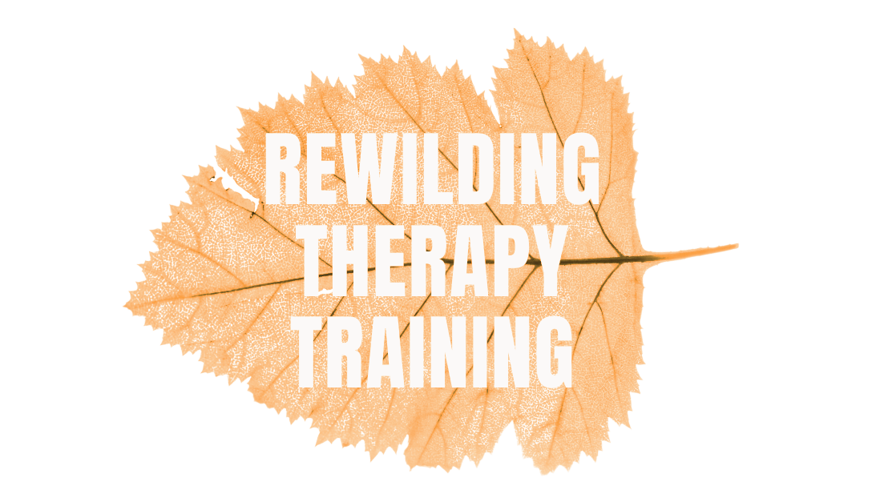

Rewilding Therapy Training
2026 Courses
Booking Form

Thank you for your interest in our Rewilding Therapy Training CPD weekend. Please complete this form in full and if you have questions, email: info@clearrising.com

Please confirm which course(s) you would like to attend:

I confirm, I would like to attend:
Part One: spring equinox March 21 - 22 2026 - YES / NO
Part two: Summer solstice June 20 - 21 2026 - YES / NO

Please provide your personal details

Full name:
Date of birth:
Address:
Email address:
Phone number:
Emergency contact (Name, relationship, phone):
Your professional and educational background
Current occupation:
Relevant qualifications or experience (including any previous rewilding CPD or related training):
Your motivations to attend this training
Why are you interested in this CPD course?

What do you hope to gain or apply after attending?

How did you hear about this course; e.g. Word of mouth, Social media, Website, Email, if other, please state?

Course fees, payment details and cancellation policy
Cost: £210 per weekend or £390 if both courses are booked together.
- A non-refundable deposit of £80.00 is required to initially secure your place.
- The full course fee must be paid by:
  - 6th March 2026 if attending the first part and / or both parts
  - 5th June 2026, if attending just the second part of the training
- Instalments can be made, via discussion and agreement. Please email michelle@clearrising.com to discuss further.
- To pay by bank transfer: Bank: Lloyds Bank, Name: Clear Rising Consultancy Ltd, Sort Code: 30-98-97, Account Number: 81835560
  - Please reference with your initials/RW0526
- Once we have received your full payment, you will be sent an invoice receipt. Your booking will be considered provisional until full payment is received.
Terms & Conditions
- Participant cancellations: If you cancel within 7 days or less before the event start date, we will retain 100% of your payment, unless we are able to fill your place, in which case, we will issue a refund minus the deposit.
- Event cancellation: If the course is cancelled by us (e.g., due to insufficient numbers, instructor illness, or weather-related issues), you will receive a full refund or the option to transfer to a future date. We are not responsible for travel, accommodation, or other costs incurred in such circumstances.
- CPD Certificate: you will be issued a digital certificate to confirm your attendance following the event.
Acquiring consent
- I confirm I agree to the course terms and conditions. Yes / No
- I consent to photos/videos being taken for promotional use. Yes / No / Only with my face obscured
- Every now and then, we send out newsletters and emails with information and announcements about our other training, CPD courses, and support services. Would you like to be added to the Clear Rising mailing list? Yes / No
Privacy & Data
We will store your personal data in accordance with GDPR. Your information will be used only for course administration and communications relating to this course.

Signature: Date:

Please return the completed form by email to info@clearrising.com
Thank you very much for your booking.
We are looking forward to meeting you.

